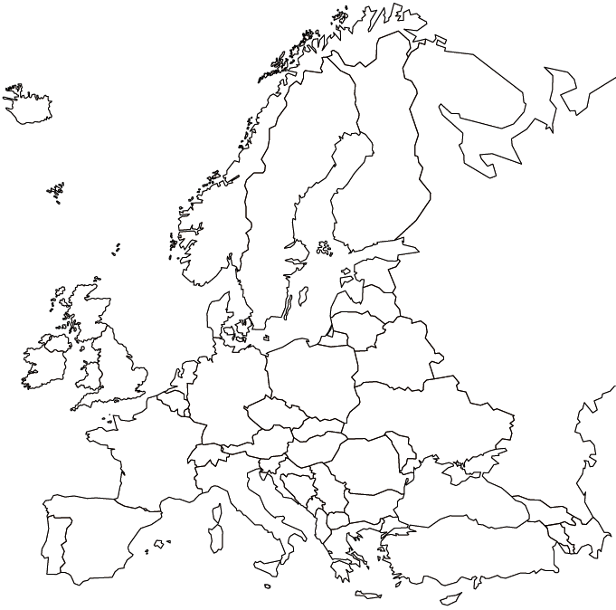
30
29
28
27
26
25
24
23
22
21
20
19
18
17
16
15
14
133
9
12
11
10
8
7
6
5
4
3
2
1
- Iceland | - Finland | - Sweden
- Norway | - Denmark | - United Kingdom
- Ireland | - Belgium | - Netherlands
- Portugal | - Spain | - France
- Switzerland | - Italy | - Germany
- Poland | - Czech Republic | - Austria
- Hungary | - Macedonia | - Greece
- Cypress | - Bulgaria | - Romania
- Belarus | - Ukraine | - Estonia
- Latvia | - Lithuania | - Russia

