NAME ________________________________________________

World History Review
(use a dark color other than black like red, blue, or green to input your answers)

- The _______________ River is the longest river in the world.
- The banks of the aforementioned river are called the _______________.
- Upper Egypt is the _______________ part of Egypt.
- _______________ is the stone most things in Egypt are made out of.
- The pyramids were most likely built by slaves
True | False
- The _______________ was the head of the state and seen as a god.
- Egyptian pictoral writing is called _______________ and means “sacred carvings.”
- The ancient language was written by _______________.
- This pictoral writing was written on _______________.
- __________ is the main Babylonian god.
- King named __________ (ruled 1792-1750 B.C.) became the greatest ruler of this new empire.
- __________ wrote Hammurabi’s Code.
- The kind of writing the Babylonians used is called __________.
- The Babylonians had a __________ calendar.
- Which of the Seven Wonders of the Ancient World came from Babylon?
- Where is Babylon located? There are 4 or 5 answers that are acceptable that come from the PowerPoint and my lecture. Be as descriptive as you can.
- Which civilization invaded and took over the city of Babylon in 1595 B.C.?
- What are 2 details Herodotus gives us about the city of Babylon?
- What is your favorite color?
20. What does Moses mother do with baby Moses after she finds out about the kings edict to kill all newborn Hebrew males?
21. What does Moses find on top of the glowing mountain?
22. What does Joshua put on the door of Dathan to protect Lillia, the woman he loves?
23. What are 3 of the miracles God performs through Moses?
24. At one point in the film Moses asks God what he should be called. What name does God give?
25. What are 3 of the Egyptian Gods?
26. What Book helps Egyptians in the afterlife?
27. In 1 way describe how an Egyptian priest looked or dressed?
28. In 2350 BC __________ from Lagash created the world’s first __________ army.
29. The Akkadian Empire is most likely the civilization that built what is known as the ______________________. 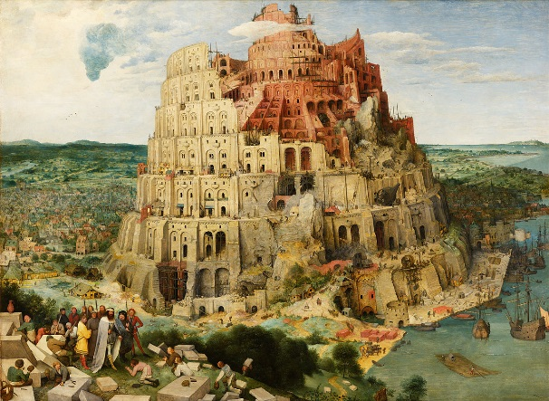
30. Who is Enheduana?
31. Who is Naram-Sin?
32. How was the Egyptians belief in resurrection rooted in what they observed each day?
33. Natron is made up of mostly 2 ingredients. What are they?
34. During the mummification process the heart was left in the body. Why?
35. The _____ is the life force or spiritual double of the person.
36. The _____ is represented as a human-headed bird that leaves the body when a person dies. The face of Ba was the exact likeness of that of the deceased person.
37. The _____ is the spirit of Re (representing light), the transfigured spirit of a person that becomes one with light after death.
38. What kind of boats do mummies travel on to go through the underworld?
39. How many gates did the deceased have to pass through to reach the Hall of Osiris?
40. In the Hall of Osiris, according to the Book of the Dead, if your heart weighs more or less than a _______________, then the goddess _______________ will devour your soul.
41. After a pharaoh passed the final test in the afterlife he would become one with which god?
42. The _______________ is a mechanical irrigation device used to put water from the canals into the fields.
43. What were the 2 main staples of the Egyptian diet?
44. What two rivers generally define the boundaries of Mesopotamia?
45. What is the name of the first known civilization?
46. What were Ziggurat’s made out of?
47. What is Polytheism?
48. A _________ is a series of rulers from one __________.
49. This first civilization created the first known system of writing called __________.
50. What is the most well-known piece of literature from this first society?
51. This first civilization developed a math system based on the number __________.
52. What color is Lapis Lazuli?
53. What kind of meat did the working class of Egypt usually have to eat?
54. What were most of the houses made out of?
55. What part of the Egyptians everyday appearance would most easily show their social stature in society (other than make-up and jewelry)?
56. What kind of Calendar did the Egyptians have?
57. How many acres does the Great Pyramid of Giza cover?
58. What number does 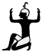 represent?
59. Small fishing boats called skiffs were made of _______________.
60. What significance is there to the many images of Pharaoh’s hunting?
61. Pick 1 of the 2 and define it. Artifact or Culture
62. Give 3 non-food benefits to early society that were due to Agriculture.
63. Define Pre-History.
64. What are 2 of the 6 common characteristics to cities?
65. What was the 1st real style of writing called? (not cave paintings)
66. Who wrote Hammurabi’s Code?
67. What were the first calendars based on?
68. Mentuhotep II was the Nomarch of Thebes. During the 39th year of his 51 year reign, he succeeded in re-unifying all of Egypt, thus beginning the ____________-______________.
69. Amenemhet extended Egypts southern border 200 miles to the ____________ Cataract.
70. What was the “Story of Sinuhe” and the “The Story of the Shipwrecked Sailor” about?
71. Thutmose III was called the ___________ of Egypt as he was short.
72. Amonhotep II executed the Seven Princes of Tikhsi on a stage in front of a crowd with a __________.
73. Thutmose IV had a dream. What was it?
74. Amenhotep III made Egypt richer than it had ever been mostly by the tributes he received from the Nubians/Kushites. He is mostly remembered as one of Egypts greatest builders and for being the first Pharaoh to marry a commoner. What did he build for his wife Tiye?
75. Tell me about the lives, accomplishments, and weirdness of Akhenaton (Amonhotep IV) and his wife Nefertiti as well as their effects on Egyptian society.
76. Mentuhotep II was the Nomarch of Thebes. During the 39th year of his 51 year reign, he succeeded in re-unifying all of Egypt, thus beginning the ____________-______________.
77. Amenemhet extended Egypt’s southern border 200 miles to the ____________ Cataract.
78. What are 3 of the military advancements that made it so easy for the Hyksos to take over the Egyptians?
79. Even though the Hyksos were good rulers, why were they hated?
80. It is during the Hyksos period that the Story of _______________ takes place. This is also the longest ongoing part of the Bible.
81. What outrageous order did Apophis give to Seqenere knowing that he would disobey? What excuse did he use to give that order?
82. How did Seqenere die?
83. This Pharaoh expanded the border south to the 3rd cataract and East to the Euphrates River. He also started the tradition of Pharaohs being buried in the Valley of the Kings. Which Pharaoh is it?
84. Which Pharaoh married his half-sister Hatshepsut?
85. Tell me any 2 facts about Hatshepsut other than she was a she, the first female Pharaoh, or that she was married to a Pharaoh that was her half-brother.
86. Who is King Tut’s father?
87. Why is Tutankhamon famous?
88. Why did Tutankhamon die so young at the age of 18?
89. Ramses II had over __________ children and over __________ wives.
90. At the age of __________ Ramses II was a captain in the Egyptian army.
91. Ramses used _______________ slaves for building projects.
91. How many ruling Ptolemy’s were there before Rome took over?
92. Who did Cleopatra have a son with?
93. How did Cleopatra die?
94. How did Mark Antony die?
95. Macedonian King _______________ took over all of Persian Empire including Egypt where he built Alexandria.

