The Depiction of History in Seven Samurai

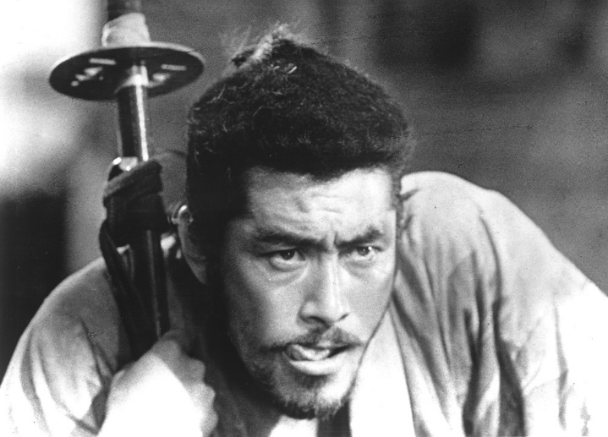
Seven Samurai, Kurosawa's film about a village that hires several samurai (not seven!) to defend it from bandits, is a remarkable meditation on history. Seven Samurai may not be very accurate in depicting late medieval society (the conflicts between peasants and samurai apply much more to the Tokugawa period), but it does focus beautifully on crucial questions for our understanding of that era. In the mythos of Japan, the sixteenth century offers some of the same possibilities as the Western frontier. There are no wide open spaces, but the age is associated with the social and economic freedoms realizable in a realm in upheaval. It is known primarily as a time of warfare and political disorder, but the era also saw the beginnings of the social engineering that would separate warriors from peasants and establish the samurai as a distinct, elite status group. The various conflicts that the film stages-the marauding bandits against the villagers and samurai, the tensions between the samurai and the villagers-are possible for other periods of Japanese period, yet they take on particular importance in this period because the final outcomes are not yet set.
Code or Duties of a Samurai
Do not criticize moral and social traditions.
Do not lead of life of personal desire.
Think little of yourself.
Think much of others.
Do not desire much in your life.
Do not regret much in regard to yourself.
Do not envy others' success.
Do not regret parting.
Do not harbor resentment against others.
Do not love too deeply.
Do not hate.
Do not build houses which are too beautiful or too big.
Do not eat too much, or too rich foods.
Do not possess many clothes; don't wear fine garments or jewels.
Do not be superstitious.
Do not spend money on anything other than your sword.
Do not fear death in serving your master or helping others.
Do not possess too much money.
Respect the Buddha and the gods, but don't pray to or depend on them.
Uphold honor without fearing death.
Never forget the way of the samurai.

Sengoku era
Tokugawa period

“This has been called the greatest Japanese film ever made, and so it is….It is one of the most influential films ever. From any angle you choose—scripting, storytelling, acting, directing, camerawork, editing—this film is a masterpiece. Every element in it is superlative…. You could take any four minutes of this film, anywhere in the picture, and find more concentrated filmmaking than you’ll find anywhere else in cinema.”
—Stephen Prince, from the Commentary on the Criterion edition of Seven Samurai
Seven Samurai is a film that exhausts superlatives. The consensus among film scholars is that it is not only the greatest Japanese movie ever made, but belongs on the shortest of short lists of the greatest films ever made. Donald Richie, the dean of Japanese film studies in English, has called it the greatest Japanese film, while David Desser, author of numerous books on Japanese cinema, says that it is “One of the greatest, if not the greatest film of all time.” Joan Mellen agrees, adding, “There’s no question but that Seven Samurai is not only a classic but a masterpiece, perhaps the greatest Japanese film ever made. Certainly it’s a member of anyone’s Top Ten list of the best films in the history of cinema. Seven Samuraiis Akira Kurosawa’s finest film.” It routinely tops lists of the greatest Japanese films, whether lists by critics and scholars or more by popular publications like Kinema Jumpo.
What is perhaps most astonishing about Seven Samurai is that this is one of those rare—indeed, unique—films that not only obsesses critics, scholars, and directors, but delights fans, whether they normally watch foreign films or not. It is a film that serves as a gateway drug not only to Japanese but to world cinema. I once showed this film to a group of junior high and high school students, all of whom protested beforehand about being forced to watch a film that was not only in B&W, but one that was subtitled. Afterwards virtually all had enjoyed the film, and several stated that it was one of the best films they’d ever seen. Seven Samurai may be technically breathtaking, but it is also enormously entertaining. This is seen most clearly in the fact that although the film is three and a half hours long, it feels much shorter, and the pacing is that of a briefer film. At the last scene, one feels that it has ended too soon.
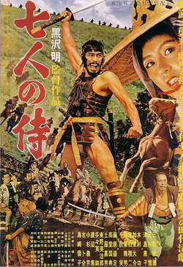
It is also a film that one can never come entirely to the end of. One can watch it once just for the thrill of the story, another time to notice what Kurosawa has done to move the narrative forward; another time to notice details of character development; another time to analyze how he uses diegetic and nondiegetic sound and music; another time to marvel over the breathtaking cinematography and editing; and then one more time just to get a blast out of it. It is also a film that gets better every time you see it (I personally have now seen it around twenty-five times, and eagerly look forward to seeing it next week when it comes out on Blu-ray).
Seven Samurai, in short, just might be the greatest film ever made.
During the American Occupation of Japan after WW II, those Americans overseeing the Japanese film industry discouraged the production of films set during feudal Japan. The fear was that the values reflected in that historical period would inhibit the move towards democratization and hearken back to the militaristic values that had made possible Japan’s involvement in WW II to begin with. (To be fair, and as Kurosawa himself frequently noted, the censorship exercised by the Americans was much preferable to censorship by the Japanese military, which Kurosawa regarded as psychotic.) Although several excellent historical films (or jidaigeki) were made in the years prior to Seven Samurai, including such superb movies as Life of Oharu, Ugetsu, and Kurosawa’s own Rashomon, none had been chambara or sword films featuring samurai. During the days of the late occupation Kurosawa had been contemplating doing a jidaigeki that would revolutionize the samurai film in Japan. Seven Samurai certainly did that and more.
Instead of the ritualized and artificial fighting that characterized most previous chambara, the fight scenes in Seven Samurai were messy and exceptionally realistic. Farmers trying to kill a bandit who has fallen off his horse and is trying to escape on foot might be thrust at a couple of dozen times before someone finally lands a crippling or lethal blow. In the climactic battle scene in the mud and rain, samurai and farmers fall repeatedly, slipping and struggling to keep their balance in the slush. This was without question the most realistic depiction of battle ever portrayed up to that point in the history of cinema. But Seven Samurai did more than bring realism to action scenes and sword fights: it brought to the sword film the same kind of realism of character development found in the best of contemporary dramas.
The plot of Seven Samurai is deceptively simple: peasant villagers hire seven samurai to defend them from attack by a large gang of bandits. But that does little justice to the film as Kurosawa uses this simple plot as a means of embarking on a complex exploration of class at a pivotal period in Japanese history and by implication asking what that meant for Japanese in the early 1950s, a similar period of social upheaval.
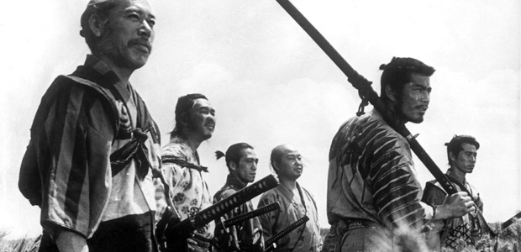
Most jidaigeki films (a term that refers to films set in the Tokugawa period and earlier, so that Kurosawa’s first directorial effort, Sanshiro Sugata, set in the 1870s and 1880s, is not considered a jidaigeki) had been set in the Tokugawa period, i.e., in the period after the unification of Japan by the military leaders Oda Nobunaga (1534-82) Toyotomi Hideyoshi (1536-98), and Tokugawa Ieyasu (1542-1616) (all three of whom would appear as characters in Kurosaswa’s 1980 film Kagemusha). The terminal point for the jidaigeki was 1868, when by legal decree Japan began the process of modernization and democracy, which entailed all rigid classes, including the samurai class. But Kurosawa preferred instead the Segoku era, or the period of civil war in the late 16th Century in which Nobunaga and his successors defeated local daimyō, bringing more and more areas of Japan under their control, while leaving thousands of samurai masterless, or ronin. Seven Samurai, Throne of Blood, The Hidden Fortress, Kagemusha, and Ran were all set in the Segoku era. The ronin in Seven Samurai were certainly among those defeated by Nobunaga or Hideyoshi.
After unification in the early 17th century samurai were no longer warriors, but instead served as administrators and bureaucrats. Thus Kurosawa chronicles in his film the twilight of the samurai as a warrior class. This is hinted at in several ways in the film, most obviously in the coda to the film following the final battle when the leader of the samurai, Kambei, tells his fellow samurai, with whom he has fought and survived battles before, that “Once more we have lost,” and explains that it is the farmers who have won. The impending demise of the samurai class is also foreshadowed by the fact that the samurai who die are killed by firearms.
The film hints also at the great change in class implemented in the Tokugawa period, in which it would be impossible for anyone to move from one class to another. In Seven Samurai we see the interplay between the samurai and the farmers, groups strictly separated by class, but not yet to the degree they soon would be. Kurosawa shows throughout the stupidity, in his opinion, of such class division (just as he would later often lament the economic inequality that increased following the embrace by Japan of free market capitalism). We see it as tragic that a young samurai loves a farmer’s daughter yet is forbidden from being together by class distinctions that are unnatural constructions. We see it also in the film’s most popular character, the faux samurai Kikuchiyo (Toshiro Mifune), who though born a farmer and completely lacking in the manners or self-discipline of a samurai, is a fearless soldier and is, later acknowledged as being a samurai in an unusual way.
Read the rest After Viewing

Some of the greatest individual character sketches in the history of cinema
Despite telling a story of class distinction, Kurosawa nonetheless provides some of the greatest individual character sketches in the history of cinema. While one of the themes of the film is that group needs trump individual ones (such as when the outlying huts are left unprotected in order to strengthen the defenses of the main part of the village), nonetheless these are vivid, strongly demarcated individuals.
The leader of the samurai, Kambei, is one of the most heroic characters in any of Kurosawa’s films. In fact, the other most heroic Kurosawa character is Watanabe, the bureaucrat dying of stomach cancer in Ikiru who is intent on building a public park in place of a cesspool before he dies. Both characters are played by Takashi Shimura (though bizarrely Seven Samurai would be Shimura’s last lead role for Kurosawa, most of the rest of his appearances in Kurosawa’s films being more or less cameos) and his transformation from the weak, dying Watanabe to the heroic Kambei is nothing short of miraculous.
Kambei is an aging, tired samurai, a survivor of many campaigns who no longer has hopes of being the warlord he dreamed of being as a young man. Yet the deep compassion that defines him is seen early in the film, when he cuts off his topknot, one of the distinguishing marks of a samurai, and shaves his head in order to impersonate a Buddhist monk so that he can get close enough to a kidnapper to rescue the child. After being approached by the farmers to ask for his help for the bandits, he initially decides not to help them, explaining that the task is too difficult and he is too tired of fighting. He changes his mind, however, when he recognizes the depth of the suffering of the farmers. In one of the films greatest images, Kambei accepts the bowl of rice they have offered him, the taking of which seals their pact, the camera capturing the outstretched bowl in the foreground and the disconsolate farmers in the background. Without Kambei, it is unlikely that the farmers could have found anyone else who could have helped.
Kambei recruits a small but superb group of samurai, including Katsushirô, a young and apparently well-to-do samurai (not only are his clothes a bit nicer than the others, but he is able to toss a number of coins to the peasants when their last of their rice is stolen) who wants to be his disciple; Gorobei, who joins because he finds Kambei fascinating; Heihachi (played by Kurosawa regular Minoru Chiaki), a good natured, humorous samurai found by Gorobei while chopping wood for a meal; Shichirôji, an old companion of Kambei’s, who is, like him, a survivor; and Kyûzô, a master swordsman and killing machine who joins for reasons that are never explained. And then there is Kikuchiyo (Toshiro Mifune), a swordsman who is most definitely not a samurai either by training, birth, or self-discipline. Although the others are at first hesitant to accept him, he proves himself to be an utterly fearless and a fierce fighter, as well as the essential mediator between samurai and farmers. He is also revealed to have been born a farmer’s son, making him a link between the samurai and the farmers.
The farmers are not as sharply delineated as the samurai, but there are a number we get to know extremely well, especially the three played by regulars in Kurosawa films: Rikichi (Yoshio Tsuchiya, in his first appearance in a Kurosawa films), Manzo (Kamatari Fujiwara), and Yohei (the mournful-faced Bokuzen Hidari).
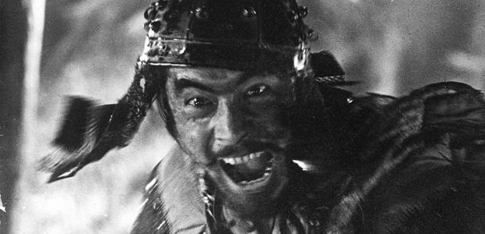
The technical innovations in the film have had a continuous impact on film and even on television. The TV series Friday Night Lights and Caprica are examples of literally hundreds of shows or movies indebted to Kurosawa. Like all of Kurosawa’s films from Seven Samurai on, both series utilize three cameras. The technique originated in Seven Samurai and was perfected in Kurosawa’s next film, I Live in Fear (aka Record of a Living Being). In the film’s various action scenes Kurosawa wanted to capture as much of the action as possible, largely for purposes of continuity in editing. And the results were indeed spectacular. The multi-camera set up allowed some wonderful editing choices; it allowed him to be, as Joan Mellen as pointed out, the true heir to Sergei Eisenstein, in that he was able to tease out the full potential in montage. Kambei notches an arrow and releases it; cut to an arrow striking home in the back of a bandit. Kikuchiyo slashes at a rider; cut to a body hitting the ground. A bandit is knocked off his horse; the fall to the ground is captured by three cuts. As commentators have noted, nothing like this was being done in Hollywood.
The three camera setup made this possible. Furthermore, in using them he made an additional discovery. Utilizing multiple cameras allowed scenes to run through their entirety with complete continuity for all three cameras. As the practice evolved, the “A” camera would capture the primary line of sigh, while the “B” camera would be set at a 90 degree angle from the “A”. The “C” camera, if used, would film at a slightly different angle form the “A” camera, providing a variety of interesting choices in the editing process. The other major benefit of using multiple cameras was that actors had to play towards one another instead of a camera. The acting became more natural, more like stage acting.
Another technical innovation was using slow motion at key moments to intensify the action. To many this will not seem all that unique, since hundreds of movies and television episodes have utilized slow motion in the same way. But this is one of the reasons why Stephen Prince, in the quote noted at the beginning of this essay, called this one of the most influential films ever made. What Kurosawa originated has been used again and again. When Kambei mortally wounds the kidnapper who then he runs out of the hut, we watch a series of cuts of the kidnapper running in slow motion spliced with reaction shots of Kikuchiyo filmed at normal speed. The effect is impressive. Later, when Kyûzô kills his opponent in a duel, we watch the dead man fall slowly over onto the ground.
These two scenes were key in creating the grammar of modern screen violence. In fact, if you take these slow motion scenes just mentioned and the Eisensteinian montage from the battle scenes, and then add in the end of Throne of Blood, where Toshiro Mifune is struck or barely missed by an absolutely staggering number of arrows, and finally combine all of them with the duel in Sanjuro, in which the title character (played by Mifune) with one blow strikes his opponent’s heart, creating a huge torrent of blood, and you get all of the elements that would later show up in directors like Arthur Penn, Samuel Fuller, and Sam Peckinpah. There was nothing in the stylized endings of Bonnie and Clyde or The Wild Bunch that had not already been seen in Kurosawa.
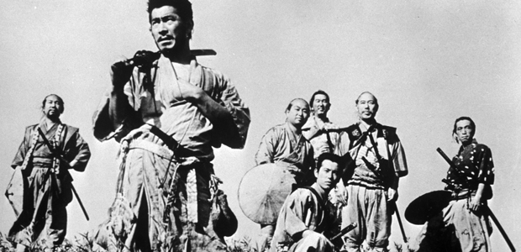
Seven Samurai is, in short, movie magic. An entire film course could be taught around analyzing all its aspects. But its greatest virtue, despite its stunning technical brilliance, is how truly entertaining it is. After viewing it—even once, but especially if seeing it many times—one is imprinted with a host of unforgettable images, such as:
- Yohei slinking off to safety behind a post when Kambei asks Katsushirô to test prospective samurai by striking them with a stick.
- Kambei charging the rebellious farmers, his sword held low, when they throw down their spears and refuse to help.
- The six samurai and their farmer guides high on rocks as they look down upon Kikuchiyo—not yet one of them—holds a fish he has caught up with his bare hands up over his head in triumph.
- A woman who lives with the thieves seeing smoke from a fire that threatens them all, beginning to cry out, then a vengeful smile cross her face, and finally an expression of peace at what is about to happen.
- Kikuchiyo, mortally wounded, killing the bandit chief with his last strength, and falling on the bridge, his legs sprayed, apart, the rain gradually washing the mud off his exposed buttocks.
- Kikuchiyo’s passionate speech in which he condemns the farmers in the most comprehensive fashion, and then equally condemns the samurai for making them what they are.
- Kambei and Kikuchiyo in the stream in front of a burning mill, the latter holding the baby handed to him by its dying mother, looking in horror at Kambei, exclaiming through his sobs, “This was me!”
- The final unforgettable moment of seeing the outline of the graves of the four dead samurai—Kikuchiyo in death considered one of them—as Fumio Hayasaka’s gorgeous samurai theme plays over the final image.
This may well be, as those noted above have said, the greatest Japanese film and perhaps even the greatest film ever made. It may be more; it may be the perfect film.
Now that you have seen Seven Samurai, thoughtfully write at length about how the movie made you feel, what it means to be a Samurai and a Ronin, as well as any notable differences to the Japanese working class culture then and our own now.

- What era is it?
- Why are all the farmers crying?
- What will the bandits take next?
- What does the “old man” say the village should do?
- What does the samurai do to his hair?
- Why does he borrow the monk’s robes?
- What do the farmers eat?
- How many Samurai did the “old man” actually think they would need?
- How does the drunk man try to prove he is a samurai?
- What do they take from the drunken samurai?
- Why does the man cut his daughters hair?
- How many scouts are sent?
- What happened to the old man?
- By the end of the film, how many samurai are left?
- In the end Kambei says that the farmers have won and that they are the ones who have lost. What do you think of this?
- Of all the Samurai: Kambei, Kikuchiyo, Shichiroji, Katsushiro, Heihachi, Kyuzo, Gorōbei or Farmers: Old Man, Rikichi, Manzo, Shino, Yohei… which is your favorite and why?

